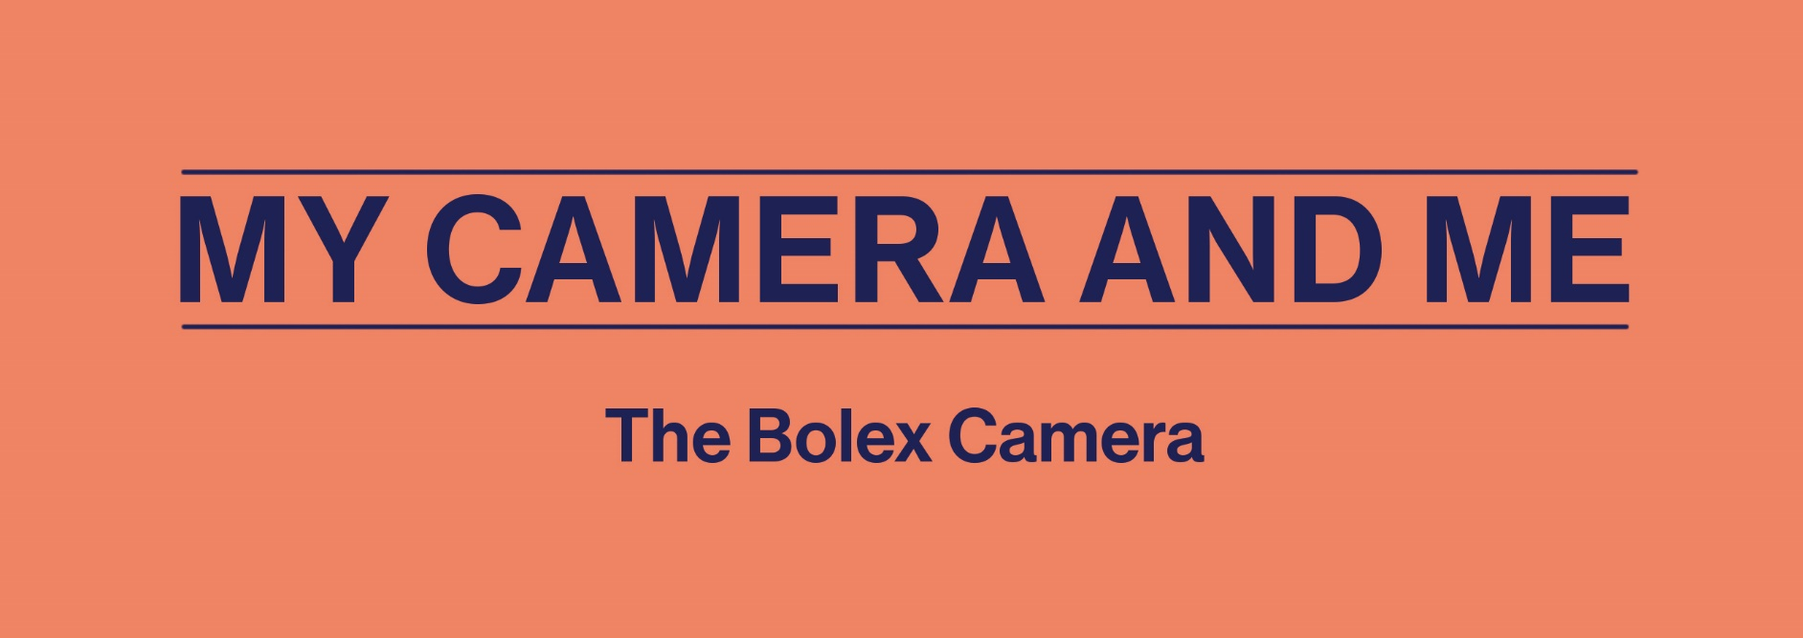

Through an auditory experience, students will discover a camera that was popular with amateur and experimental filmmakers alike: the Bolex. This activity is based on Secondary 2 English as a Second Language and Visual Arts competencies. It aims to introduce the characteristics of this camera to students by having them organize information in an entertaining way.

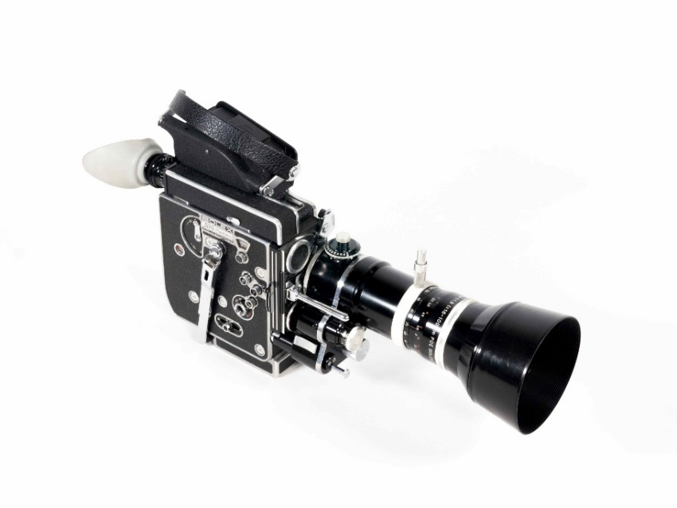
16 mm Paillard Bolex H16 REX-5 Camera
Lemai Collection , L.sc.1176
TECHNÈS CC BY-SA 4.0

This activity is based on the academic curricula of the following subjects:
- English as a Second Language, Cycle One (Secondary 2)
  - Competency 1: Interacts orally in English
  - Competency 2: Reinvests understanding of texts
- Visual Arts, Cycle One (Secondary 2)
  - Competency 3: Appreciates works of art and cultural objects from the word’s artistic heritage, personal images and media images

Background of the creation of this camera
This content may be shared by the teacher to introduce the activity.

In the late 1920s, the Paillard company, which until then had produced music boxes, gramophones and typewriters, decided to diversify its activities. It purchased the cameras, laboratories and numerous patents of engineer Jacques Bogopolsky. Bogopolsky was the inventor of transportable “automatic” cameras like the Auto Ciné Models A and B. Paillard wished to create a camera with multiple functions. In doing so, the company bucked the prevailing trend of designing simple cameras for inexperienced users.
After five years of development, the Bolex Model H16 was launched in 1935. The H16 was a commercial success in the 1960s, both in the USA and elsewhere. Its arrival on the market marked a turning point for the use of 16 mm film as a professional format. Until then, professionals had relied on 35 mm film for its superior quality. The Bolex H16’s versatility encouraged them to work with 16 mm film on a more regular basis.
This ingenious, easy-to-use camera was especially popular with amateur and experimental filmmakers, both for documenting everyday life and experimenting with effects while shooting. The Bolex’s small size and easy handling made it ideal for filming oneself and one’s friends and family, capturing everyday moments, creating intimate portraits, recording important memories and revealing a subject’s personality or emotions. Perhaps you do the same with the devices of today!

Learning Activity
To learn about the background of the Bolex H16 camera and discover its features, students are invited to listen to the Bolex H16 podcast in the Podcast Journeys section of the website, either in class or at home.

- Listen to the podcast and pay close attention to what the narrator says, the elements of her explanation and her reasons for talking about it. Feel free to take notes as you listen. Then, answer the following questions:

- Who do you think is narrating this podcast? ________________________________________________________________
- For whom is she creating a short film, and why? _______________________________________________________________
- The narrator provides a lot of information to help contextualize the invention of this camera.

  - In what year did the Paillard company launch the Bolex camera? _____________________________________________________________
  - What were this company’s initial activities? _____________________________________________________________
  - Why was this compact camera so important to the amateur and experimental film movements?
_____________________________________________________________
_____________________________________________________________
  - To what does the narrator compare the size and weight of this camera? __________________________________________________________________________________________________________________________
- Taking as an example the film made by Joyce Wieland in Toronto, the narrator describes the Bolex’s features.
  - How long (in minutes) does it take to shoot a reel of 16 mm film? _____________________________________________________________
  - Does Joyce Wieland have to go into a darkroom to switch film reels? _____________________________________________________________
  - With the Bolex, it is possible to experiment with various in-camera visual effects. Name two of the examples provided.
__________________________________________________________________________________________________________________________
  - When Wieland is hiding behind the parked car, what does she use to gradually move closer to her friend through the car window while remaining physically distant, and what is this effect called? __________________________________________________________________________________________________________________________
  - Given that the Bolex does not have a sound recording system, how did experimental filmmakers like Wieland and Frampton add music to their films? __________________________________________________________________________________________________________________________
  - Does this camera need to be plugged into an electrical outlet during use? __________________________________________________________________________________________________________________________
- Would you like to see a clip from A and B in Ontario, which was directed by Joyce Wieland and Hollis Frampton in 1967? Head over to the Discover the Cameras section of the website and click to view the Bolex page. You’ll be able to explore the features of this camera and discuss them with your classmates.
- Where is the scene filmed (indoors or outdoors)?
- How many people does it take to operate this camera?
- How do Joyce Wieland and Hollis Frampton position their hands when holding the camera?
- Where is the operator’s eye placed?
- Is the camera connected to a power source?
- Where can the crank for winding up the spring-operated motor be found?
- Is the camera mounted on a tripod?
- At what moments is the zoom lens used (either for moving closer to the subject or for moving away)?
- Was the film’s soundtrack recorded at the same time as the video?
- Are the shots long or rather short (in other words, do we always see the same image in the film or do the views change)?

Answer key for the teacher

- Listen to the podcast
- A young person who likes to shoot videos with her telephone.
- For her grandmother’s surprise birthday party.
- About the Bolex H16:
  - The Bolex camera was launched in 1935.
  - The production of objects, such as music boxes and typewriters.
  - The camera allows amateurs to shoot films (such as family portraits) and experimental filmmakers to push the boundaries of artistic creation.
  - She compares the size of the camera to a long novel and its weight to that of a Chihuahua.
- Features of the Bolex:
  - A reel of 16 mm film lasts four minutes.
  - No, she does it outside, in the shade of a tree.
  - The Bolex is capable of adding overlays, dissolves, fast motion and slow motion.
  - She uses the zoom lens, and the effect is called a zoom movement.
  - They sometimes collaborated with sound artists to create soundtracks.
  - No. After about 40 seconds of shooting, the crank handle on the side of the camera must be used to wind up the spring-operated motor. Shooting can then continue.

- Clip from A and B in Ontario, which was directed by Joyce Wieland and Hollis Frampton in 1967. The following are some possible answers for discussion with the class:
- It was filmed out of doors (the students may also recall that it was filmed in Toronto).
- The camera is operated by one person.
- The Bolex must be held with both hands. The operator’s right hand holds the underside of the camera and the left hand passes through the leather handle to grip the top of the camera.
- The operator’s eye is placed against the viewfinder to frame the shot while filming. The filmmaker can both see what is being filmed and move about freely.
- No. The spring-operated motor must be wound up every 40 seconds or so.
- On the side of the camera.
- No. Operators can easily move around while using this camera.
- Early in the clip, Wieland zooms in to get a close-up shot of Frampton. When Frampton winds up the spring-operated motor, Wieland zooms out.
- Because the camera does not have a sound recording system, sound was produced separately and then added to the soundtrack.
- The camera can only hold 30 metres of film, so operators must contend with short shots.

