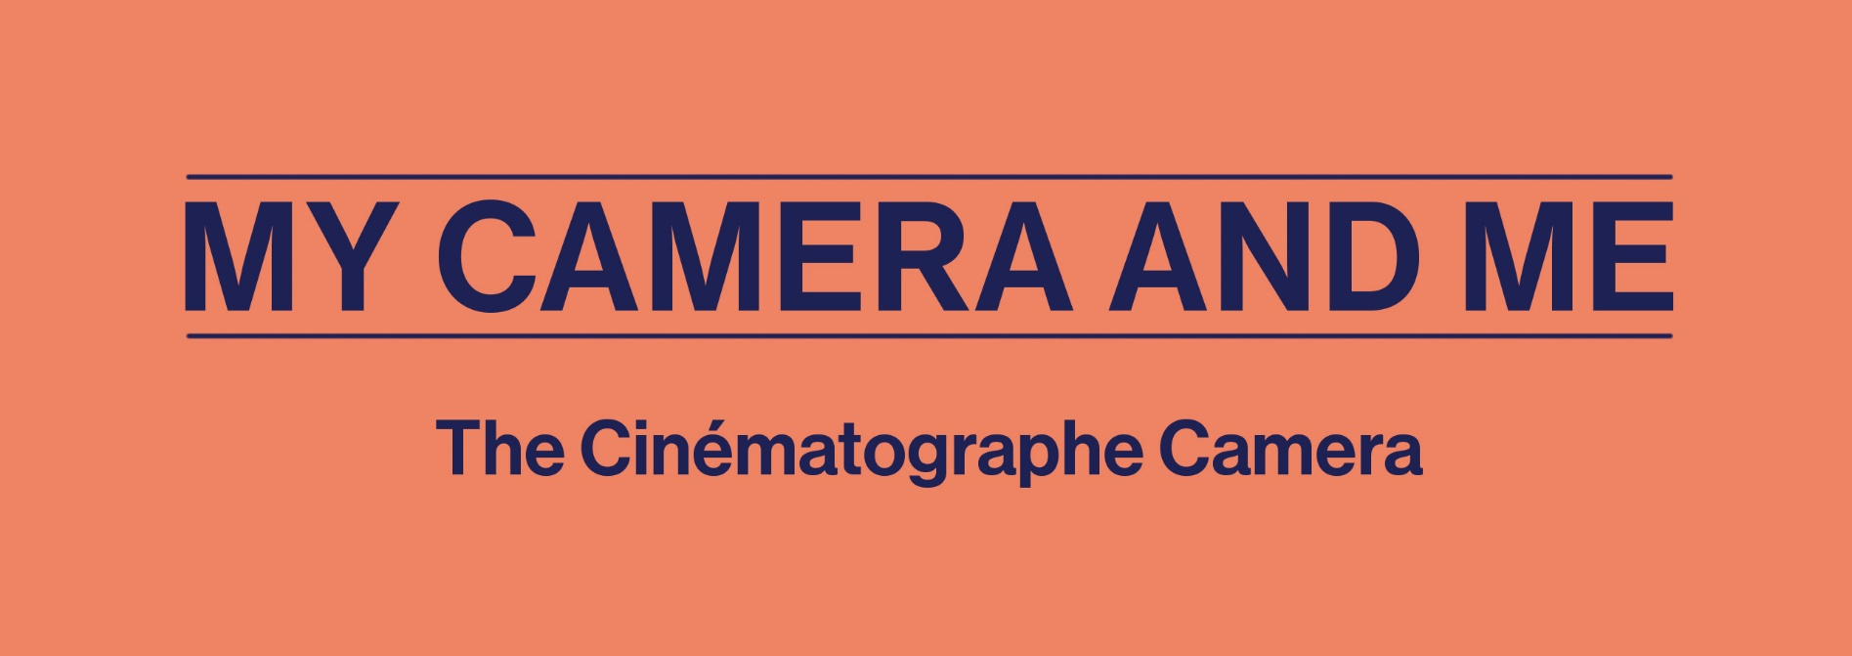

With the Cinématographe camera, filmmakers could shoot a variety of scenes reflecting both everyday life and the industrialization of society. Drawing on competencies from the Secondary 3 Visual Arts curriculum, this activity aims to characterize the Belle Époque historical period in Europe (1890-1914) using examples shot by this camera. Students will be invited to produce a short, silent film to experience how cameras provide subjective ways of seeing the world.
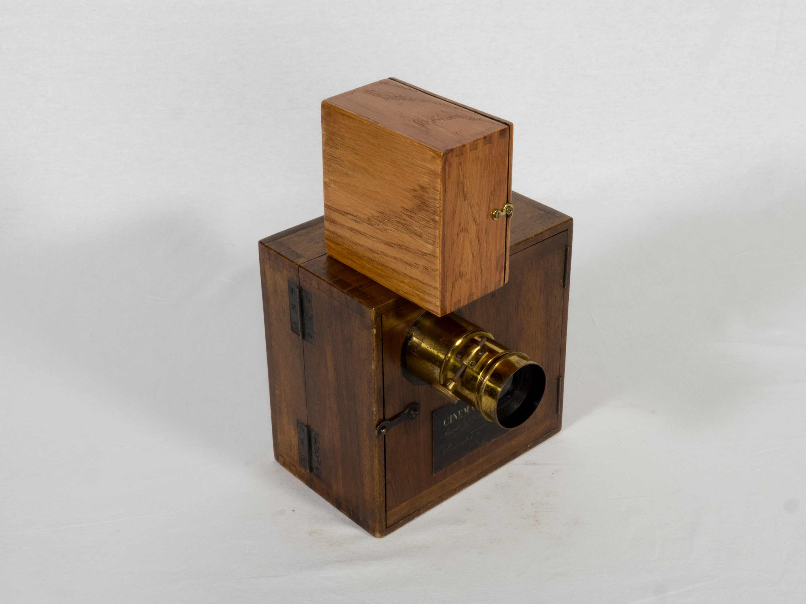
Lumière-Carpentier Cinématographe 35 mm Camera/Printer/Projector
Collection Cinémathèque québécoise 1995.0218.01-17. AP
TECHNÈS CC BY-SA 4.0

This activity is based on the academic curriculum of the following subject:
- Visual Arts, Cycle Two (Secondary 3)
  - Competency 1: Creates personal images
  - Competency 2: Creates media images
  - Competency 3: Appreciates images

Background of the creation of this camera
This content may be shared by the teacher to introduce the activity.

The Belle Époque was characterized by a period of progress, industrial development, technological innovation (including movie cameras), scientific discovery and travel. During this period, the upper classes revelled in luxury and the working classes, which had secured certain employment benefits through trade unions, shared in the general sense of optimism. In France, posters conveying society’s enthusiasm for entertainment and leisure covered Morris columns, walls and fences, especially in the capital. The newly emerging art of cinema contributed to this quest for amusement by opening the doors to a world of wonders via animated views, as they were called at the time.

The Cinématographe, a portable, crank-powered camera (no electricity required), which was also reversible (it could record scenes, produce a positive image from a previously developed negative and project it), was able to film outdoor scenes of everyday life. However, once it was mounted on its tripod, it could no longer be moved. This meant that shots had to be carefully prepared (location, camera angle, framing) to ensure the entire scene fit into the 50 seconds of shooting time permitted by a reel of film in the camera’s magazine. Essentially, scenes from everyday life could be recorded, but this had to be done through organized shoots...providing an illusion of uncontrived action. Occasionally, short sketches or stories (such as L’Arroseur arrosé) were filmed, but for the most part, scenes were of a documentary nature and depicted France and the rest of the world at the turn of the 20th century (memoirs of Félix Mesguich).

In Europe, the Belle Époque was also a period of colonial expansion. In the West, the new movie-going public was curious about these animated views that had been filmed all over the world (Porte de Jaffa : Côté est) and that revealed “exotic” countries and cultures. Although these views aroused curiosity about the world, they also reinforced the colonialist belief that the people whose customs seemed so different and strange needed to be “civilized,” or that the distant lands providing new goods and materials to Europe had to be subjugated.

Learning Activity
For this activity, students are invited to read about the Cinématographe in the Discover the Cameras section of the website, and to watch the clips called Bains en mer, Course en sac and Porte de Jaffa : côté est. While watching, they should pay special attention to elements depicted in the film and consider the contexts within which the films were shot. Next, working alone or in small groups, they are invited to produce a short film inspired by the animated views of the Lumière brothers. Through this activity, students will become aware that point of view and subjectivity are inherent to documentary filmmaking.
For this project, students will shoot their film—in a single, long take—using a digital camera or cell phone. The film must be shot from a fixed point and cannot exceed 50 seconds. Students will have to prepare the scene before shooting it, since they will not be allowed to do any editing.
The project can be completed in three steps:
- Synopsis
- To begin, students should determine whether they will present an everyday activity, introduce viewers to a new location or portray one or more characters (extras can be used).
- Next, they will select a location for their shoot. The location itself must be static, but ideally it should be a place of activity (hallway, library, cafeteria, schoolyard, etc.).
- They will then choose a fixed camera angle (frame the shot*) from which they will capture the images.
- Shoot
The students will shoot their scene in a single 50-second take, without moving the camera, as per their previously determined synopsis.
- Projection
The completed documentaries can be presented in class, without sound (since all animated views created with the Cinématographe were silent). They can then form the basis for a class discussion or a written report.
  - Compare two documentaries filmed in the same location, but using different camera angles, etc.
  - Formulate (or write) what you understood about one of the films you watched (again, for comparison purposes).

